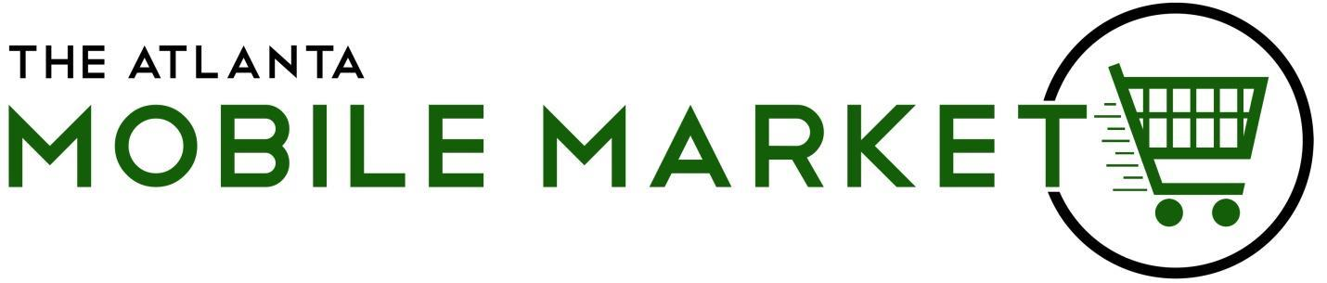

APPLICATION FOR COMMITTEE MEMBERS AT THE ATLANTA MOBILE MARKET
*NOTE: PLEASE INCLUDE RESUME*

NAME ______________________________________________________

TELEPHONE ________________________________________________

ADDRESS ___________________________________________________

(STREET) (CITY) (STATE) (ZIP CODE)

EMAIL ______________________________________________________

DESCRIBE EMPLOYMENT OR OTHER TRAINING WHICH WOULD BE USEFUL TO THE ORGANIZATION:

LIST HOBBIES, SKILLS, AND INTERESTS:

DO YOU HAVE ACCESS TO TRANSPORTATION?____________________________
AVAILABILITY? [Workday(s), evenings, weekends, etc.]

IS THERE A PARTICULAR PART OF NON-PROFIT MANAGEMENT OR FOOD ACCESS ON WHICH YOU WOULD LIKE TO WORK? (e.g., volunteer recruitment/management, community outreach, grant writing, fundraising, program design.)

